1. This is screenshot of internet access from private instance after NAT gateway creation to allow one way outward connection from the instance.

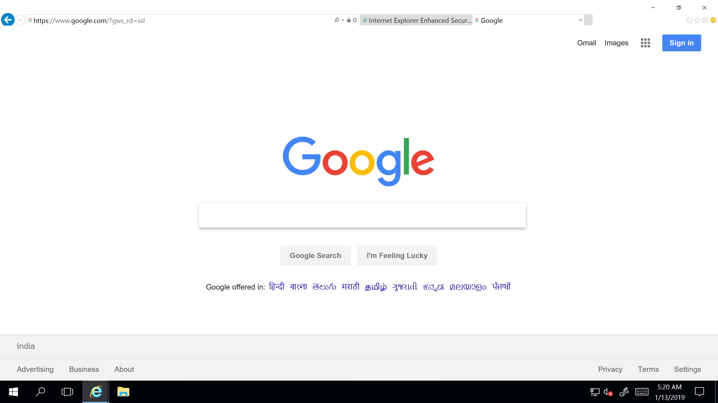

1. This screenshot is of the private instance desktop showing the private ip.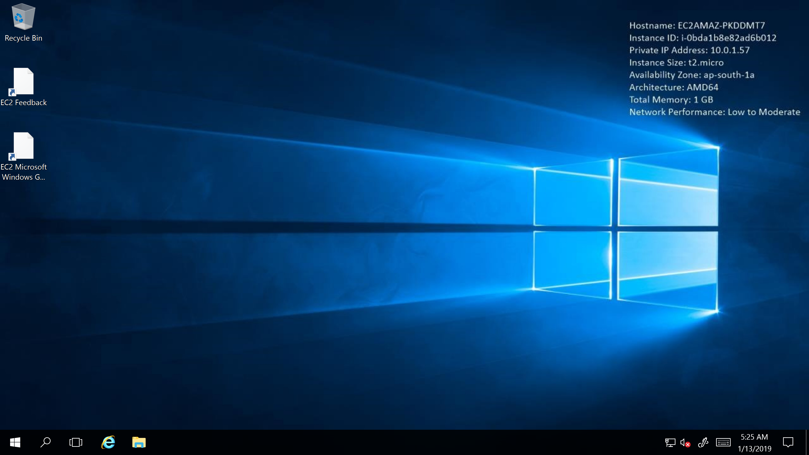
2. This screenshot is of the public instance with it’s public ip and private ip.

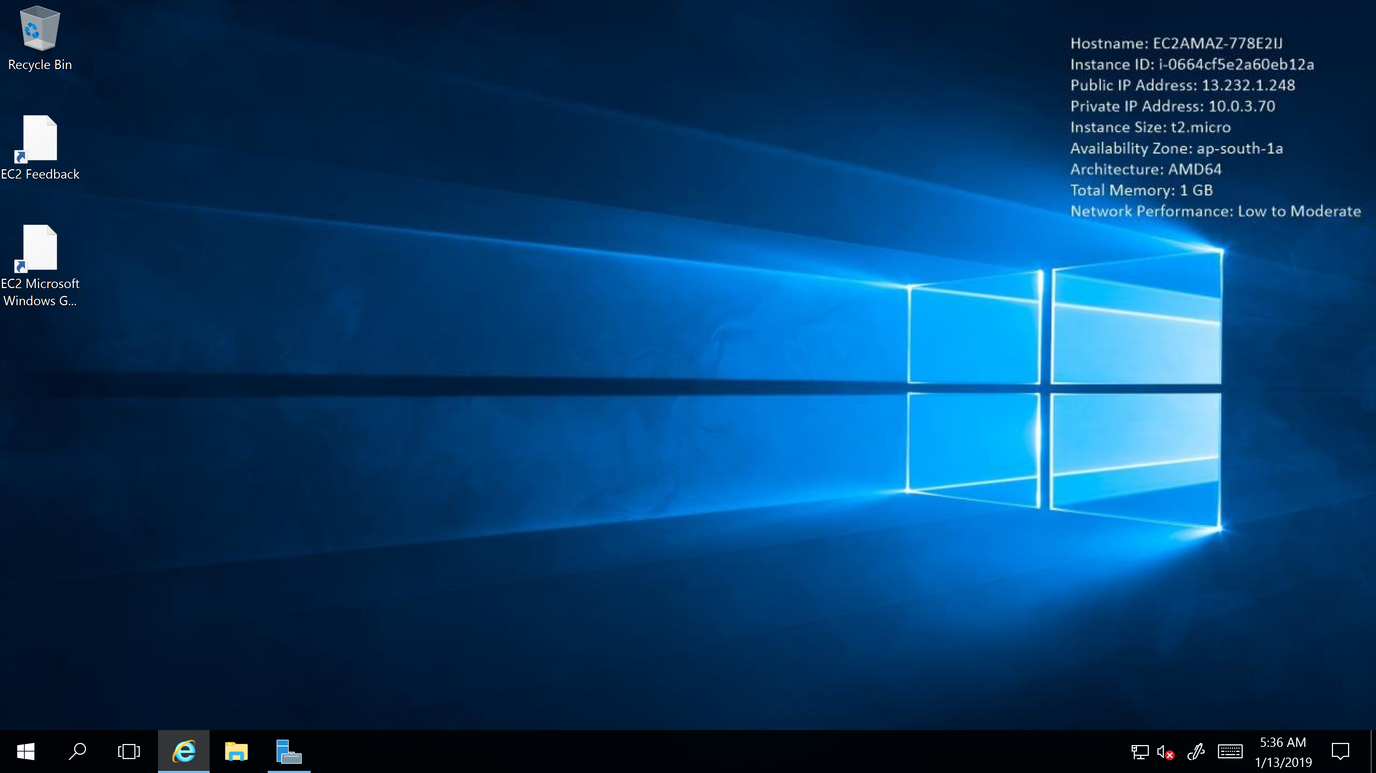

1. This screenshot is of the private route with nat gateway linking.

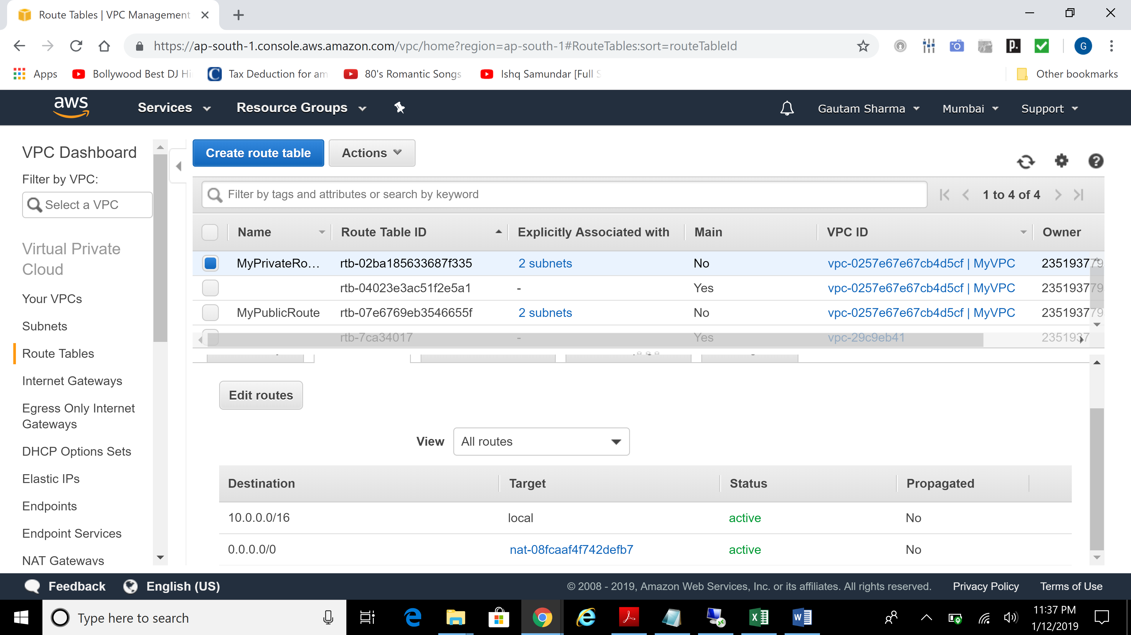

1. This screenshot is of the nat gateway.

